
Drones Corridor
Quick Start Guide
Updated January 2, 2025


Prepared For:
Defense Logistics Agency

Revision History

Revision Date | Author | Summary of Changes
12 / 19 / 2025 | Joe Pilling | Initial Draft
1 / 2 / 2025 | John Carrithers | Finalized Initial Draft

Table of Contents
- What is FedMall? How do I access it? 4
- How do I authenticate to FedMall? 4
- What is the Drones Corridor? 4
- Using the Drones Corridor 5

What is FedMall? How is it Accessed?
FedMall is an e-commerce ordering system for Department of Defense (DoD), Federal, State, and authorized local Agencies to search for and acquire products from government reserves and commercial sources. Buyers will have access to tens of millions of individual items of supply, from centrally managed DoD and General Service Administration (GSA) assets to commercial off-the-shelf (COTS) products, and the most recently added Drones Corridor.
To access FedMall via PIEE (Procurement Integrated Enterprise Environment), users must first register on the PIEE website (piee.eb.mil) using their CAC/PIV or Software Certificate, choosing the appropriate FedMall role in the profile. New users must register, while existing users can log in via PIEE SSO and click the FedMall icon, which directs them to the correct portal (Commerce). Note: Please reference the Drones Customer Registration QSG for detailed instructions if needed.
- As a customer, you will access FedMall by visiting: https://www.fedmall.mil

Authenticating to FedMall?
To access the FedMall Commerce Portal, a User will need to authenticate (identify) themselves with any of the following:

- Common Access Card (CAC): a credit card sized smart card issued by the DoD to uniformed service personnel, DoD civilian employees, and eligible contractors. For more information, visit: http://www.cac.mil/common-access- card/getting-your-cac/
- Personal Identify Verification (PIV) card: a credit card sized smart card issued by the U.S. Federal Government in accordance with Homeland Security Presidential Directive 12 (HSPD-12) requirements for a common identification standard for all Federal employees and contractors. For more information, visit: http://fedidcard.gov/credget.aspx
- Public Key Infrastructure (PKI) certificate: As an alternative to the physical smart card, you may also obtain a software-based X.509 certificate, which you import a file into your browser’s personal certificate store. For more information, visit: http://iase.disa.mil/pki/eca

What is the Drones Corridor?
The Drones corridor was added to the FedMall release version FM 26.1.5. The Drones corridor in Commerce offers easy access to search and purchase UAS and C-UAS Drones. UAS is considered the drone plus its control station and comms, while C-UAS systems are considered the security system against UAS threats.
The new corridor provides a dedicated storefront for FedMall users to search, browse, and select from a variety of drone products. All drone items may be purchased from FedMall using MILSTRIP Fund Code.

Using the Drones Corridor
The Drones search corridor in Commerce offers a collection of UAS and C-UAS drones. All items within the corridor are payable via MILSTRIP Fund Code.
Corridor Navigation
1. Once logged into Commerce, click the Corridors option in the main navigation bar to view available search corridors and click “DRONES”.

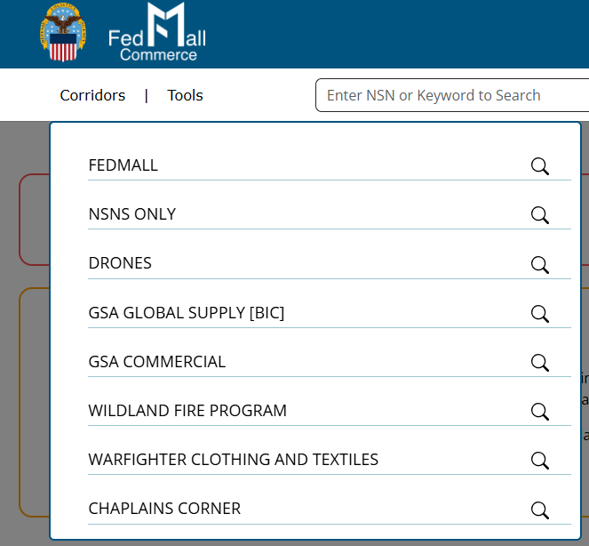
2. Then click “ALL DRONES” or “AIRCRAFT/AIRFRAME STRUCTURE COMPTS”.
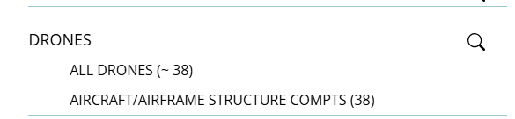

3. A list of drone search results will be displayed.
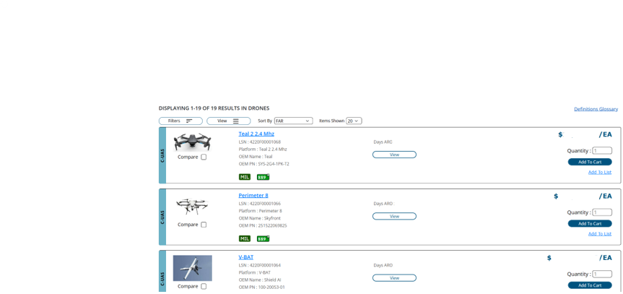

4. Click the  button to change search results from list view to grid view.

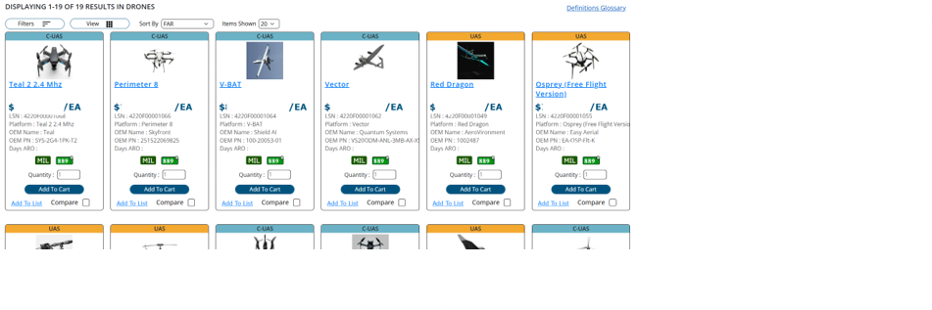

Compare Function
Click the Compare checkbox on multiple drones to start a compare list.
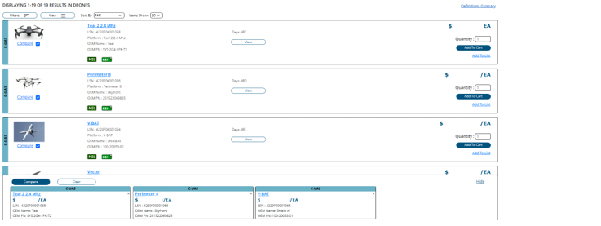
Then click the  button to compare additional details for the selected drones.
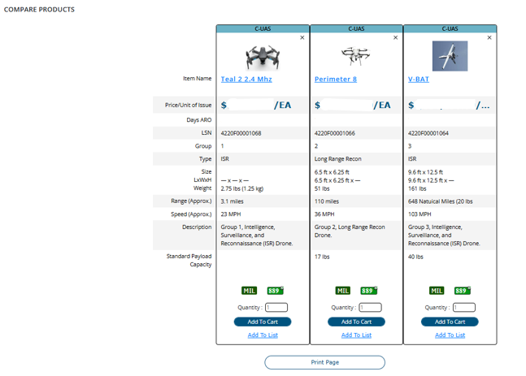
Product Detail Page
On the search results page or compare page, click the drone’s name or the  button to view the product detail page to view additional details about each drone.
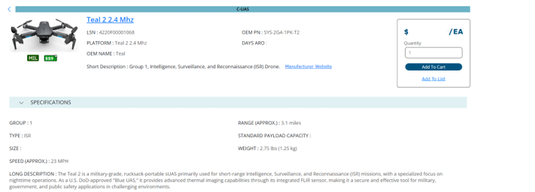

Purchase
To purchase a drone, enter the quantity and click the  button for the drone(s) to be purchased from any of the search pages, compare page or product detail page, and the drone(s) will be added to the cart. To complete the purchase, click the button.
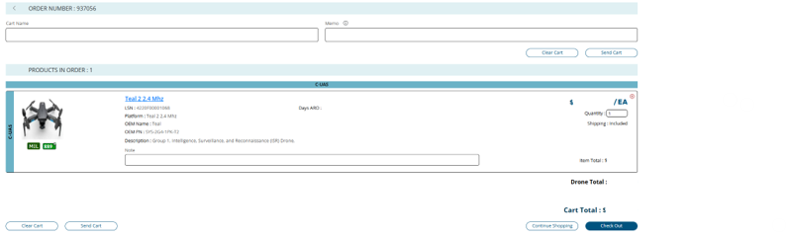

Checkout
On the Checkout page enter MILSTRIP payment, shipping, billing information, and click the  button.
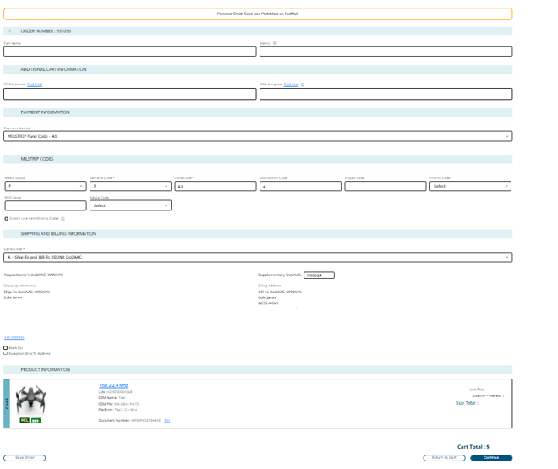

9. Once the order is placed, an order confirmation email will be sent to the user.

10. Orders can also be viewed by click on  at the top of the page, then click on “Orders” at the bottom of the list to view orders placed:
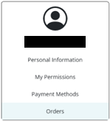

Requisitioning:
All requisitions for drone items are processed and routed through the Defense Automated Addressing System (DAAS). Requisitions placed from FedMall are passed as DLMS 511R transactions to DLA Enterprise Business System (EBS) for fulfillment.

